DSC 478 Executive Summary
Massiel Payero Garcia

This analysis utilizes a World Health Organization dataset to identify key factors influencing life expectancy across 2352 observations. Using machine learning techniques, the study can provide insights for public health policy and resource allocation decisions. Multiple machine learning techniques were used in this analysis, including multiple linear regression, random forest, and kmeans clustering.
The dataset contained a large amount of missing data. Where possible, missing values were replaced with the column mean for each country. Largely empty columns were deleted, then rows containing missing values. After data cleaning and preprocessing, 80% of the data remained to work with. Irrelevant and redundant columns were also dropped.
For multiple linear regression, both training and testing data resulted in RMSE values under 5.000. Being that the age range in the dataset was 36.3 – 89.0, this was a desirable outcome. Both training and testing RMSE values were similar to each other, suggesting that the model is not overfitting. Ridge, Lasso, and Elastic Net regression were also investigated. Once tuned for ideal values of alpha, the models displayed similar results.
Bins were created to represent ‘life expectancy’ for Random Forest. ‘Low’ represented 0 - 60 years. ‘Medium’ represented 60 - 75 years. ‘High’ represented 75 – 90 years. It was determined via Grid Search that the best parameters were the following:
'criterion': 'entropy', 'max_depth': None, 'min_samples_split': 5, 'n_estimators': 50
When these parameters were used, it resulted in an accuracy of 0.932.
It was determined that the primary factors positively influencing life expectancy were income composition of resources, schooling, and BMI. The factors that most negatively influenced life expectancy were HIV/AIDS and thinness 10-19 years. These results were determined by both multiple linear regression and random forest.
Kmeans clustering was used to investigate if there were clear , separable differences between countries labelled as ‘Developed’ and countries labelled as ‘Developing’. Two clusters were created for this. The elbow method was used to investigate if there was an ideal number of clusters that should be used, but the plot did not plateau and was inconclusive. Cluster 0 contained 1432 items. Cluster 1 contained 920 items. Based on the centroids, it was determined that cluster 0 represented ‘Developed’ countries and cluster 1 represented ‘Developing’ countries.
Clustering was effective at creating a separate cluster that only contained 'Developing' countries. However, many ‘Developing’ countries ended up in cluster 0 with ‘Developed’ countries. In reality, these statuses are not clearly defined and there might be several 'Developing' countries that are close to transitioning to 'Developed' status, thus getting clustered together. Cluster 1 likely represents ‘Developing’ countries that are struggling more severely.

DSC 478 Final Project Report
Massiel Payero Garcia

Introduction
The dataset used for this project is the Life Expectancy (WHO) dataset from Kaggle.com (https://www.kaggle.com/datasets/kumarajarshi/life-expectancy-who). This dataset contains 2938 rows and 22 features. Three features are categorical (country, year, and status). 19 features are numerical (life expectancy, adult mortality, infant deaths, alcohol, percentage expenditure, hepatitis B, measles, BMI, under-five deaths, polio, total expenditure, diphtheria, HIV/AIDS, GDP, population, thinness 10-19 years, thinness 5-9 years, income composition of resources, schooling). The data type is relational, as well as temporal. Data is recorded for each country between the years 2000-2015, so each country appears 16 times.
For this project, the goal was to analyze which factors contribute to higher life expectancy. Multiple linear regression and RandomForest were used to make predictions about life expectancy. Kmeans clustering was used to analyze if there were significant differences between countries with ‘Developed’ and ‘Developing’ statuses.

Data Cleaning and Exploration
The ‘Year’ column was dropped due to being irrelevant. The original dataset contained 2563 missing values. The columns ‘Hepatitis B’, ‘GDP’, and ‘Population’ each contained over 400 missing values. To fix this, the missing values were replaced with the column mean for each individual country. After this, there were still 1698 missing values. These were cases where countries had no recorded data for at least one column, so there was no column mean for that country. The ‘Population’ column still had about 22% of its values missing, so the column was deleted. This left 1050 missing values remaining in the dataset. Rows with any missing values were then deleted, resulting in a dataset with 2352 rows. Overall, about 20% of rows were deleted during the data cleaning process.
Multicollinearity of the features was investigated. ‘Infant deaths’ was determined to be included in ‘under-five deaths’, so it was dropped to reduce collinearity. ‘Percentage expenditure’ was highly correlated with ‘GDP’, so it was dropped. ‘Thinness 5-9 years’ was highly correlated with ‘thinness 10-19 years’, so it was dropped.
A histogram of ‘BMI’ revealed a bimodal distribution. This could likely reflect the development ‘Status’ (‘Developing ’ vs ‘Developed’) of the countries. The ‘Developing’ status was much more heavily represented in the data (2016 vs 336).

Multiple Linear Regression
“Life expectancy” was used as the target variable for linear regression, so it was dropped from the dataset. Only numerical features were used for multiple linear regression analysis, so “Country” and “Status” were also removed. ‘Adult Mortality’ was dropped because it heavily overlapped with ‘Life expectancy’ in terms of the information it communicated. All numerical features were scaled prior to linear regression analysis to ensure coefficient magnitudes are directly comparable across features with different units and scales.
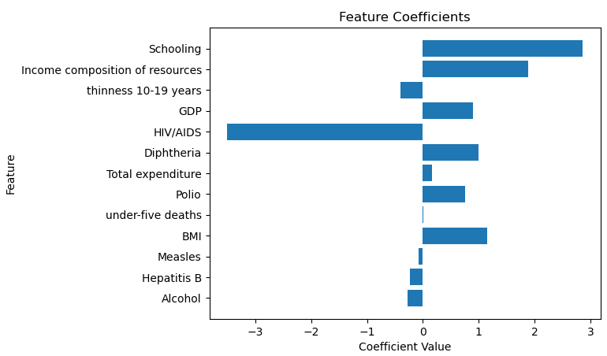
The dataset was split into 80% training and 20% testing partitions. The training partition was used to create a linear regression model. The model was used to predict the target variable for the test data. It was discovered that ‘Schooling’ had the highest coefficient value. This implies that its increase contributes the most to an increase in life expectancy. This makes sense. It has been established that a higher education generally contributes to a higher quality of life. ‘Income composition of resources’ had the second highest coefficient. ‘HIV/AIDS’ had the largest negative coefficient, implying that its increase contributes the most to a decrease in life expectancy. This makes sense because HIV/AIDS can be very deadly and lead to many deaths.
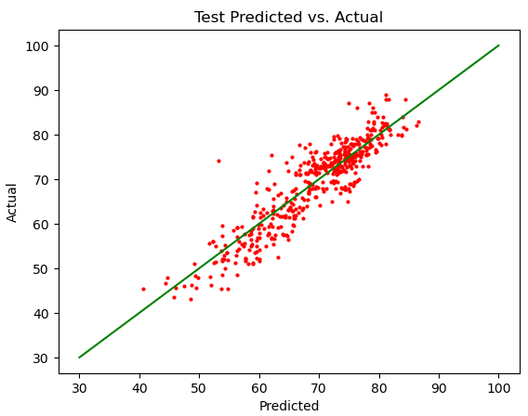
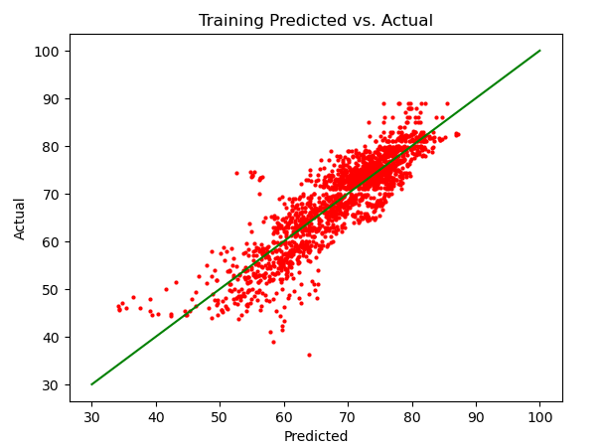
The RMSE for the training data was determined to be approximately 4.456. Considering that the range for life expectancy was 36.3 – 89.0 years, this RMSE value was acceptable. The RMSE value for the test data was approximately 3.979. This was similar to the value obtained for the training data, suggesting that the model is not overfitting.
Ridge, Lasso, and Elastic Net Regression were also performed on the data. Hyperparameter tuning was used to test different values of alpha and determine which value resulted in the lowest cross-validation RMSE score.
For ridge regression, the best alpha was determined to be 51.025. This resulted in a RMSE of 4.458 for training data and 4.001 for testing data. For lasso regression, the best alpha was determined to be 0.0227. This resulted in a RMSE of 4.457 for training data and 3.984 for testing data. For elastic net regression, the best alpha was determined to be 0.0360. This resulted in a RMSE of 4.458 for training data and 3.998 for testing data. Overall, all of these methods resulted in similar RMSE values, with the test values being lower than the training values.

Random Forest
3 bins were created to represent the data in the ‘Life expectancy’ column: ‘Low’ (0 – 60 years), ‘Medium’ (60 – 75 years), and ‘High’ (75 – 90 years). ‘Adult Mortality’ was dropped for the same reasons as before. Only numerical features were used, so ‘Country’ and ‘Status’ were dropped again. Grid search was used to determine the best parameters. These included ‘n_estimators’, ‘max_depth’, ‘min_samples_split’, and ‘criterion’. It was found that the best parameters were the following:
'criterion': 'entropy', 'max_depth': None, 'min_samples_split': 5, 'n_estimators': 50
When these parameters were used, it resulted in an accuracy of 0.932. The scores for precision, recall, and f1-score were also very high. The top three features determined to be most important were ‘income composition of resources’, ‘Schooling’, and ‘HIV/AIDS’. These are the same features that had the largest coefficient values during linear regression analysis.
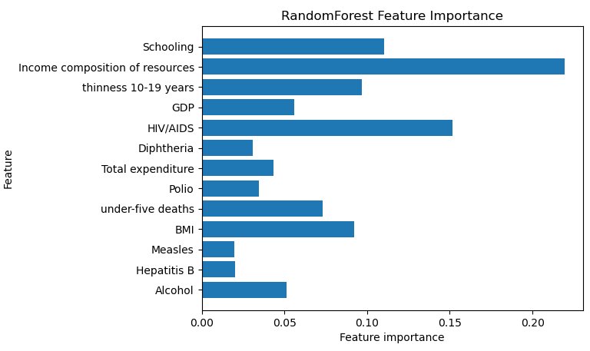
KMeans Clustering
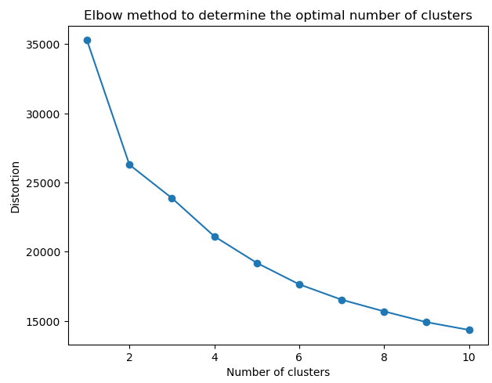
Only numerical features were used for kmeans clustering, so categorical features(‘Country’ and ‘Status’) were excluded. Data was scaled so that features with large ranges would not dominate distance calculations. The elbow method was used to determine an ideal number of clusters. However, it did not produce a clear plateau after 2 clusters, so 2 clusters were determined to be the ideal number.

2 clusters were created. Cluster 0 contained 1432 items. Cluster 1 contained 920 items. Based on the centroids, it can be speculated that cluster 0 represents 'Developed' countries, while cluster 1 represents 'Developing' countries. Cluster 0 had generally higher values for favorable features, such as life expectancy, GDP, and schooling. Cluster 1 had generally higher values for negative features, such as adult mortality, under-five deaths, and Measles.
Clustering was effective at creating a separate cluster for 'Developing' countries. However, it struggled with separating 'Developed' countries. Many ’Developing’ countries ended up in cluster 0. In reality, these statuses are not clearly defined and there might be several 'Developing' countries that are close to transitioning to 'Developed' status, thus getting clustered together. Cluster 1 likely represents countries that are struggling more severely. Results like these could be used to examine if a country’s status should be reassessed.

